Year 10 Science
Chemical Sciences
Practical - Precipitation Reactions

Aim: To observe precipitation reactions and determine the solubility of ions.

Method:
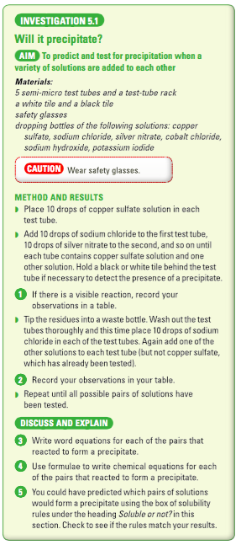

• You will be supplied with a grid on which you can test for reactions. The background is black to make it easier to observe any reactions.

• Place 1 drop of each reactant on a square and record any reaction - usually a solid coloured substance will form. Record this with a tick and the colour.

• If there is no solid produced, record this with a X.

Observations

Negative ions  Positive  ions | NaCl | NaOH | NaBr | Na₂SO₄ | Na₂CO₃ | NaNO₃
Ca(NO₃)₂
Cu(NO₃)₂
Mg(NO₃)₂
KNO₃
AgNO₃
FeCl₃
Pb(NO₃)₂

Discussion

• Do questions 3-5 above.

Conclusion:

